Standard | Items:
2.OA.01 -  Use addition and subtraction within 100 to solve one- and two-step word problems involving situations of adding to, taking from, putting together, taking apart, and comparing, with unknowns in all positions, e.g., by using drawings and equations with a symbol for the unknown number to represent the problem.  Remember to use this language in the problem. | 3.0  - Nick had 32 jellybeans in his jar. He got a bag of 27 jellybeans. How many jellybeans does he have now? Write the equation that matches the problem and solve.  - Luke had 60 rocks in his rock collection. He lost 27 rocks on Monday. On Tuesday, he found 13 of the rocks. How many rocks does he have now? Write the equations that matches the problem and solve.  - Bella had some seashells in a collection. On Saturday, She found 16 of the shells. Now she has 54 shells. How many seashells did Bella start with? Write the equation that matches the problem and solve.  - Alina and Jordyn like to jump rope at recess. Alina jumped 37 times with a jump rope. Jordyn jumped 18 fewer times. How many times did Jordyn jump? Write the equation that matches the problem and solve.
2.0
- Sara had 128 stickers. Her friend, Alex, gave her 47 more stickers. How many stickers does Sara have now?
  - What kind of problem is this:
1-step 2-step problem?
  - What is happening?
putting together taking apart comparing
Solve and show your thinking.
- ___ + 13 = 75
- 98- ___ = 52
- 65 + 32 = ___
- 87- 23=

2.NBT.07 -  Add and subtract within 1000, using concrete models or drawings and strategies based on place value, properties of operations, and/or the relationship between addition and subtraction; relate the strategy to a written method. Understand that in adding or subtracting three- digit numbers, one adds or subtracts hundreds and hundreds, tens and tens, ones and ones; and sometimes it is necessary to compose or decompose tens or hundreds. | 3.0  - Solve and show your thinking.  - 374-128  Solve and show your thinking  - 438+212  Solve and show your thinking.  - 325 + 242
2.0
- Solve and show your thinking
  - 264-133
- Susie solved 345+ 243 by adding 200 to 345 and got 545, then she added 40 more to get 385 and then 3 more to get 388. Name the strategy that Susie used to solve the problem? (have word bank, take out tools like number line and only write strategies).
- Solve and show your thinking.
  - 347 + 236

2.MD.01 -  Measure the length of an object by selecting and using appropriate tools such as rulers, yardsticks, meter sticks, and measuring tapes. | 3.0  1.  - Reed is measuring the length of his bedroom to see if his new desk will fit. Which tool should he use?  - A ruler  - A yardstick  - His shoe  b. Greg needs to find out how wide a piece of printer paper is. Use your ruler to measure the bottom of your test paper. My paper is _______ __________ long.
2.0
- Molly is hanging a birdhouse in her yard. Which tool would be most appropriate to measure the height of the tree?
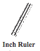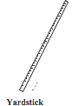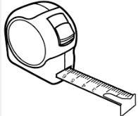Tape Measure

- How many inches long is the glue?
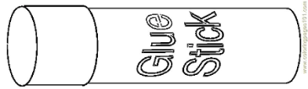

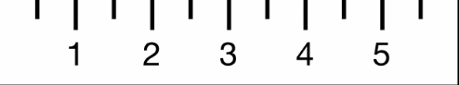

- Which tool would you use to measure a lunchbox?
2.MD.08 -  Solve word problems involving dollar bills, quarters, dimes, nickels, and pennies, using $ and ¢ symbols appropriately. Example: If you have 2 dimes and 3 pennies, how many cents do you have? | 3.0.  - If you have 4 quarters and 3 nickels, how many money total do you have?  $_______________ and _______________¢
2.0
- What is the symbol for dollars? _____
- What is the symbol for cents? _____
- 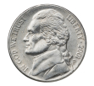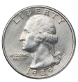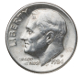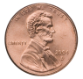
How much money is shown above? _______

4. If you have 3 dimes and 3 pennies, how many cents do you have? _________________ ¢

2.G.03 -  Partition circles and rectangles into two, three, or four equal shares, describe the shares using the words halves, thirds, half of, a third of, etc., and describe the whole as two halves, three thirds, four fourths. Recognize that equal shares of identical wholes need not have the same shape. | 3.0  - Show two different ways to divide a rectangle below into 3 equal parts.  - The rectangles are divided into  - halves  - thirds  - fourths
2.0
- Are both of these squares partitioned into equal shares?

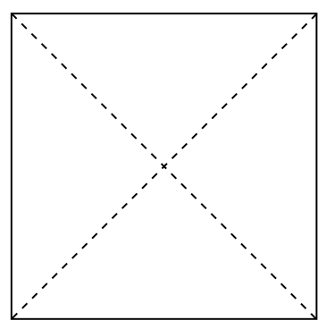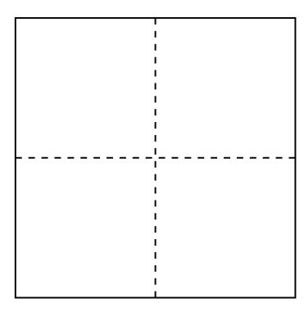

Yes or No

- Partition the circle below into halves.

- Divide the shape below into three thirds.

